**Woolf, Leonard (1880-1969)**

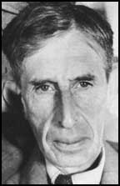

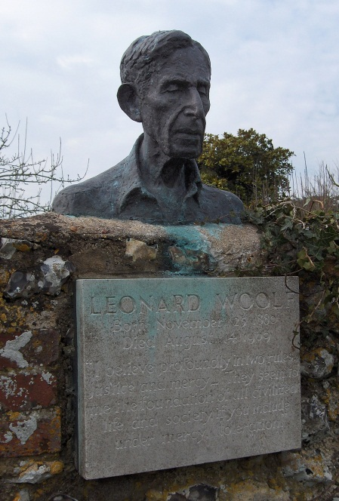Leonard Woolf was an essayist, author, political activist and publisher. He joined the Civil Service in 1904 and spent seven years in Ceylon, which experience deeply influenced not only his political views, but also his fictional writing. With his wife, the novelist VIRGINIA WOOLF, he ran the Hogarth Press, a vanguard publishing house of the period. The Press’s first publication, entitled *Two Stories*, comprised his ‘Three Jews’ and VIRGINIA WOOLF’s ‘The Mark on the Wall’. He was a committed socialist and member of the Fabian Society and Labour Party; he served as honorary secretary for the Labour Party’s advisory committees on international and imperial affairs, and stood (unsuccessfully) as a Member of Parliament for the Combined Universities 1922. An expert on international affairs, he wrote numerous volumes of political analysis. He was a founding member of the League of Nations Society; the two reports included in his book *International Government* were key documents in the formation of the League itself. He was also joint or literary editor of a number of political periodicals including the *International Review, The Political Quarterly,* and the *Nation* (later *The New Statesman*). He wrote five volumes of autobiography, the last published in the year of his death.

The bronze bust of Leonard Woolf marking where his ashes are buried in the garden of Monk’s House, the Woolfs’ Sussex home.

url: <http://commons.wikimedia.org/wiki/File:Virginia_Woolf_(3)-3.jpg>

Leonard Woolf

url: <http://www.spartacus.schoolnet.co.uk/TUwoolf.htm>

**Further reading**

Funke, Sarah (2002) *Virginia & Leonard Woolf,* New York: Glenn Horowitz Bookseller.

Glendinning, Victoria (2006) *Leonard Woolf: A Biography,* London: Simon & Schuster.

Meyerowitz, Selma S. (1982) *Leonard Woolf*, Boston: Twayne.

Wilson, Duncan, and J. Eisenberg (1978) *Leonard Woolf: A Political Biography*, London: Hogarth.

Wilson, Peter (2003) *The International Theory of Leonard Woolf: A Study in Twentieth Century Idealism*, Basingstoke: Palgrave Macmillan.

Bryony Randall, University of Glasgow